The University of Nottingham

DEPARTMENT OF MECHANICAL, MATERIALS AND MANUFACTURING ENGINEERING

A LEVEL 3 MODULE, Mock Exam

THERMOFLUIDS 3

Time allowed Three hours

Candidates may complete the front cover of their answer book and sign their desk card but must NOT write anything else until the start of the examination period is announced.

Answer ALL questions (100 marks)

Only a calculator from approved list A may be used in this examination.
Basic Models  Aurora HC133  Casio HS-5D  Deli – DL1654  Sharp EL-233 | Scientific Calculators  Aurora AX-582  Casio FX82 family  Casio FX83 family  Casio FX85 family  Casio FX350 family  Casio FX570 family  Casio FX 991 family  Sharp EL-531 family  Texas Instruments TI-30 family  Texas BA II+ family

Dictionaries are not allowed with one exception. Those whose first language is not English may use a standard translation dictionary to translate between that language and English provided that neither language is the subject of this examination. Subject specific translation dictionaries are not permitted.

No electronic devices capable of storing and retrieving text, including electronic dictionaries, may be used.

DO NOT turn examination paper over until instructed to do so

ADDITIONAL MATERIAL: Thermodynamic tables

INFORMATION FOR INVIGILATORS:

Question papers should be collected in at the end of the exam – do not allow candidates to take copies from the exam room.

Summary of useful equations and thermodynamic properties.

$$Re_{D}=\frac{U_{a}D}{ν}, Nu_{D}=\frac{hD}{k}, Sh_{L}=\frac{h_{m}L}{D_{12}}, Bi=\frac{hD}{k_{s}}$$

$$m=\sqrt{\frac{hP}{kA}}, θ\left(x\right)=θ\left(0\right)e^{-mx}, q=kA\frac{dθ}{dx}$$

$\dot{q}=-\frac{kA}{Δx}(T_{2}-T_{1})$ $\dot{q}=-hA ( T_{2}-T_{1})$

Table 1: Selected values of Thermodynamic properties of dry air at low pressure.
T [K] | $k [W/mK]×10^{-2}$ | $ν [m/s^{2} ]×10^{-5}$ | $$Pr$$
275 | 2.428 | 1.343 | 0.713
300 | 2.624 | 1.568 | 0.707
325 | 2.816 | 1.807 | 0.701
350 | 3.003 | 2.056 | 0.697
375 | 3.186 | 2.317 | 0.692
400 | 3.365 | 2.591 | 0.688

Stefan Boltzmann constant:
$$σ=5.67×{10}^{-8}W/m^{2}K$$
Thermal resistance network between two grey bodies.

$$q_{1→2}=\frac{σ\left(T_{1}^{4}-T_{2}^{4}\right)}{\frac{1-ϵ_{1}}{ϵ_{1}A_{1}}+\frac{1}{A_{1}F_{12}}+\frac{1-ϵ_{2}}{ϵ_{2}A_{2}}}$$
For questions on combustion:
$$\dot{Q}+\dot{W}=\sum_{\operatorname{Pr}{o}ducts}{{\dot{m}}_{i}(h-h_{0})}-\sum_{\operatorname{Re}{a}c\tan{t}s}{{\dot{m}}_{i}(h-h_{0})+{\dot{m}}_{f}}Δh_{0}$$
$$K^{Θ}=e^{-\left(\frac{Δ{\tilde{g}}_{\left(T\right)}^{Θ}}{\tilde{R}T}\right)}$$
$$∆G_{T}^{⊝}=\sum_{products}{n_{i}{\tilde{g}}_{i(T)}^{⊝}}; \tilde{g}=\tilde{h}-T\tilde{s}; T_{af} = T_{0}-\frac{m_{f}∆h_{0}}{\sum_{products}{m_{i}{\overline{c}}_{pi}}}$$

For questions on exergy:
$$\dot{E}=\dot{m}\left(\left(h_{1}-h_{0}\right)-T_{0}\left(s_{1}-s_{0}\right)\right)$$
$$\sum{{\dot{E}}_{in}+\dot{W}+{\dot{E}}^{Q}=\sum{{\dot{E}}_{out}+\dot{I}}}$$
For questions on gas turbines:

$$w=c_{p}\left(T_{2}-T_{1}\right)$$  $$\frac{T_{2}}{T_{1}}={\left(\frac{p_{2}}{p_{1}}\right)}^{\frac{γ-1}{γη_{∞c}}}$$ | $$\frac{T_{2}}{T_{1}}={\left(\frac{p_{2}}{p_{1}}\right)}^{\frac{\left(γ-1\right)η_{∞t}}{γ}}$$  $$w_{r}=\frac{w_{net}}{w_{gross}}$$
For questions on steam turbines with heat recovery steam generator:

$${∆h}_{gas}={{\dot{m}}_{gas}c}_{p}∆T_{gas}$$ | $$η_{isen.turbine}=\frac{actual work out}{isentropic work out}$$

1. An aircraft experiences a flow of air at Mach number 3. The deflection angle of the supersonic aerofoil is 25° as indicated in the Figure Q1. Using the shock wave angle chart provided, determine the possible outcomes of this interaction, and describe the meaning of each of them. [5]
Mach 3
25°

Figure Q1
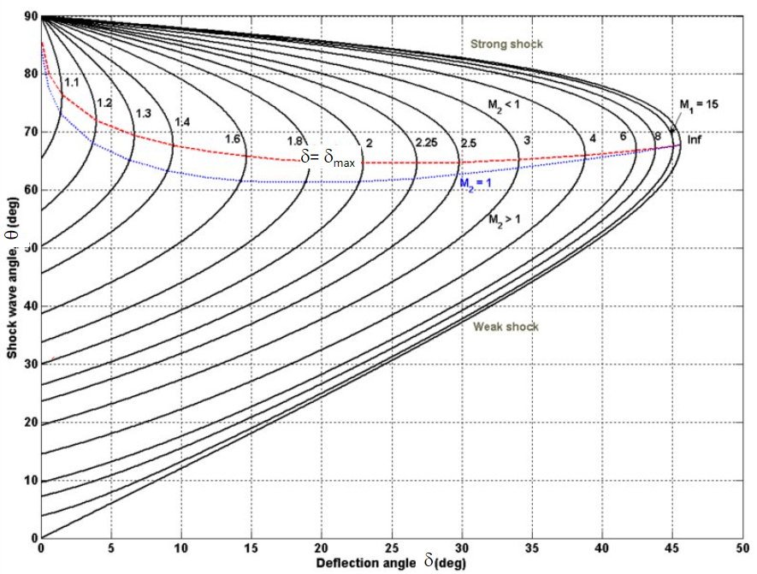
Shock wave angle chart

2. A flow of air at Mach 2 flows over the top of an aerofoil and experiences an expansion with an angle of 10°. Describe what will happen to the Mach number of the flow because of this and use the chart of turning angle vs. Mach number to determine the exit Mach number. [4]

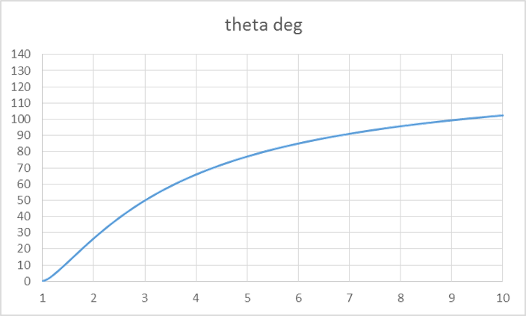
Prandtl Meyer expansion for turning angle of supersonic flows.

3. In transient heat transfer situations there are two commonly used non-dimensional numbers, the Nusselt number ($Nu=hL/k$) and the Biot number ($Bi=hL/k$).

While the equations look the same, they are different and used for different purposes.

- Rewrite these two equations using the correct parameters as defined in figure Q3. Assume that natural convection and the flow of heat is one dimensional. [6]

- In less than 250 of your own words, discuss the relative magnitude of heat applied compared to the heat conducted if the Biot number is much greater than 1, and suggest an application where this might be useful. [4]

Material properties
$$k_{m}, ρ_{m}, c_{m},α_{m}$$
Air properties
$$k_{a}, ρ_{a}, μ_{a}, c_{a},α_{a}$$
Width, W
Height, H
h.t.c. material
$$h_{m}$$
Heat applied, $Q$
Heat conducted, $Q$
h.t.c air
$$h_{a}$$

Fig Q3

4. Methane (CH₄) is combusted with 50% excess air. Both the methane and the air are at an initial temperature of 25°C. From your understanding of the Steady Flow Energy Equation and adiabatic flame temperature, explain, giving reasons, how the adiabatic flame temperature would change if:

(a) the amount of excess air was increased; and [3]

(b) the air was preheated. [5]

Write no more than about 75 words in answer to each part of this question.

A
B
C

Parameter | Value
A | 2 mm
B | 20 mm
C | 40 mm
$$k_{fin}$$ | 2 W/mK

Figure Q5

5. A rectangular cross section fin is added to a surface as shown in Figure Q5.

- Showing your working, calculate what heat transfer coefficient would be needed to get a m shape factor of $m=71 m^{-1}$. [5]

- What would be the efficiency of this fin if we make the insulated tip approximation? [3]

- If the effectiveness of this fin is 3.5, how much heat would this fin lose if the area corresponding to the base of the fin lost 10W when the fin is not present? [2]

6. One turbine row in a gas turbine has the conditions indicated in Table Q6:

density, kg/m³ | axial velocity, m/s | mdot,  kg/s
8.7 | 127 | 67

Table Q6

The hub radius of the turbine row is 0.5 m. The questions that follow concerns this turbine stage in these conditions.

- Calculate the turbine blade height based on the conditions for the stage. [5]

- The relative velocity angle going into the turbine stage is 60°, at exit it is 80° and the flow coefficient is 0.4. Calculate the rotational velocity of the turbine. Sketch a turbine blade, indicating the relative velocity vector angles on it. [6]

7. A flow of 10 kg/s of dry saturated steam at 15 bar is throttled in a pressure reducing valve to 5 bar. Calculate the rate of irreversibility in the process.
The environmental temperature is 7 °C. At the environmental temperature assume that water has an enthalpy of 29.4 kJ/kg and an entropy of 0.106 kJ/kgK. You may use Steam Tables provided to determine steam properties. [14]

8. An inventor was inspired by his trip to Egypt and decides to build a pyramid-shaped oven that is heated by radiation. The square base of the oven has side 0.48 m and the height of the apex of the pyramid above the centre of the oven is 0.36 m. Three of the triangular sides are insulated and the fourth side has a heating element installed that raises its temperature to 325 °C. All the triangular sides have the same area, which is 0.1038 m². The base is found to be at a temperature of 150 °C.

(a) Noting the symmetry of the shape, derive all of the view factors from the base (side B), the heated side (side H) and the insulated walls (side I). [10]

(b) Draw the resistance network for this problem and label it by using the nomenclature from the diagram. No surface is a black body. [10]
heated side (H)
0.36 m
0.48 m
Base (B)
3 sides unheated and insulated (I)

Figure Q8

9. A gas turbine is used for electricity generation. The turbine inlet temperature is 1000 °C, the pressure ratio is 12 and the air mass flow rate is (50 + X) kg/s, where X is the last digit of your student ID. The inlet air temperature is 17 °C. Assume that ambient pressure is 1 bar and there is zero pressure loss during combustion. Also assume that there is no change in mass flow rate due to fuel addition in the combustion chamber. The polytropic efficiency is 85% in both compressor and turbine.

Gas properties are as follows:

In compressor assume c_{p} = 1.005 kJ/kgK and $γ$ = 1.4.

In turbines assume c_{p} = 1.15 kJ/kgK and $γ$ = 1.333.

The gas turbine drives a gear box with an efficiency of 99% and the gear box drives the electricity generator, which has an efficiency of 96%.

Calculate the electrical power output from the generator. [18]
END

